**Catering**

1. **Aisya Catering**

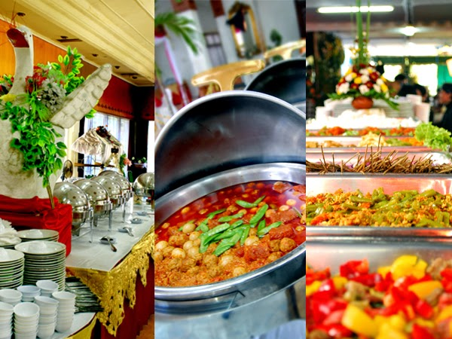

Phone : 081754647386

Address :

1. Paket 1 (30,000/orang)

Aneka Olahan Sup

Aneka Olahan Nasi

Aneka Olahan Sayur

Aneka Olahan Seafood

Aneka Olahan Ayam

Dessert

Nasi Putih

Air Mineral

1. Paket 2 (35,000/orang)

Aneka Olahan Sup

Aneka Olahan Nasi

Aneka Olahan Sayur

Aneka Olahan Seafood

Aneka Olahan Ayam

Dessert

Nasi Putih

Air Mineral

Olahan Salad

1. Paket 3 (40,000/orang)

Aneka Olahan Sup

Aneka Olahan Nasi

Aneka Olahan Sayur

Aneka Olahan Seafood

Aneka Olahan Ayam

Aneka Olahan Daging

Dessert

Nasi Putih

Air Mineral

1. **Bintang Catering**

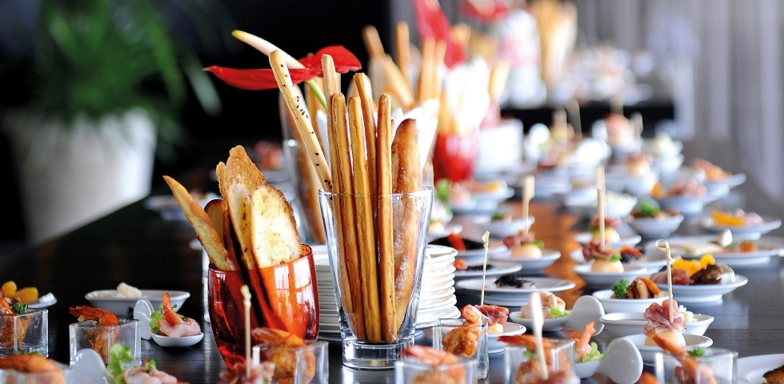

Phone : (031) 829 5564, 7013 2722

Address : Jl. Dukuh Menanggal IX/2y, Surabaya

Email: cateringbintang@yahoo.com

Note : Contact for price (custom is available)

1. **Marga Catering Service**

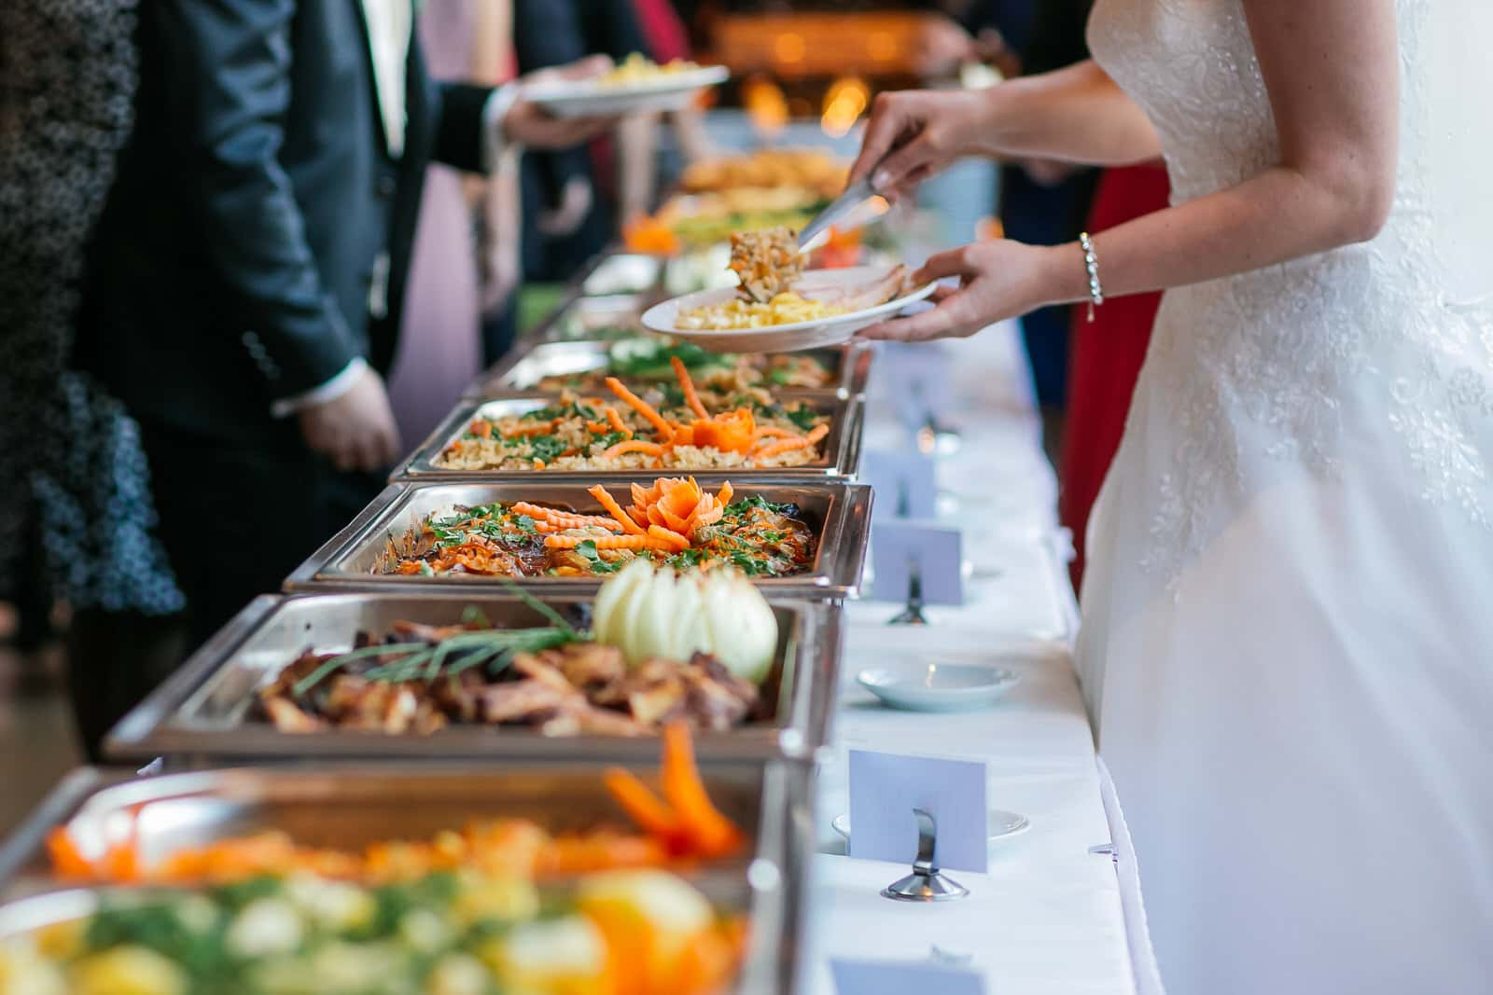

Phone : (031) 381 8265

Address : Jalan Bronggalan Sawah Gang IV F No. 67, Tambaksari, Surabaya, Kota SBY, Jawa Timur 60132

1. Paket 1 (30,000)

Nasi Putih

Sayur Asem

Pepes Ikan

Empal Daging

Bacem tempe/tahu

Kerupuk

Sambal Terasi

Es Kelapa Muda

Air Mineral

1. Paket 2 (30,000)

Nasi Putih

Rawon

Telur Asin

Tahu bumbu bali

Tempe goreng

Kerupuk

Sambal + kecambah putih

Es dawet

Air mineral

1. **Jaya Kartini Catering**

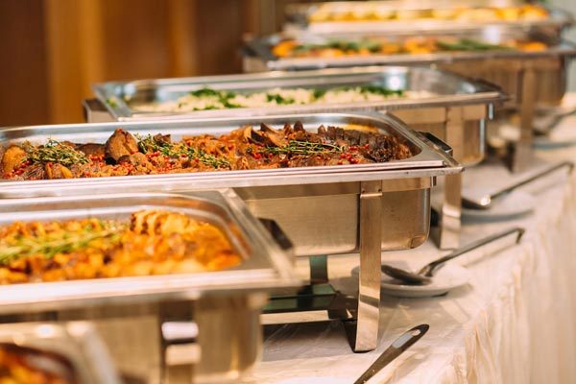

Phone : (031) 353 6335

Address : Jl. Tg Raja I No.25, Perak Bar., Kec. Krembangan, Kota SBY, Jawa Timur 60177

Note : Contact for price (custom is available)

1. **RA Catering**

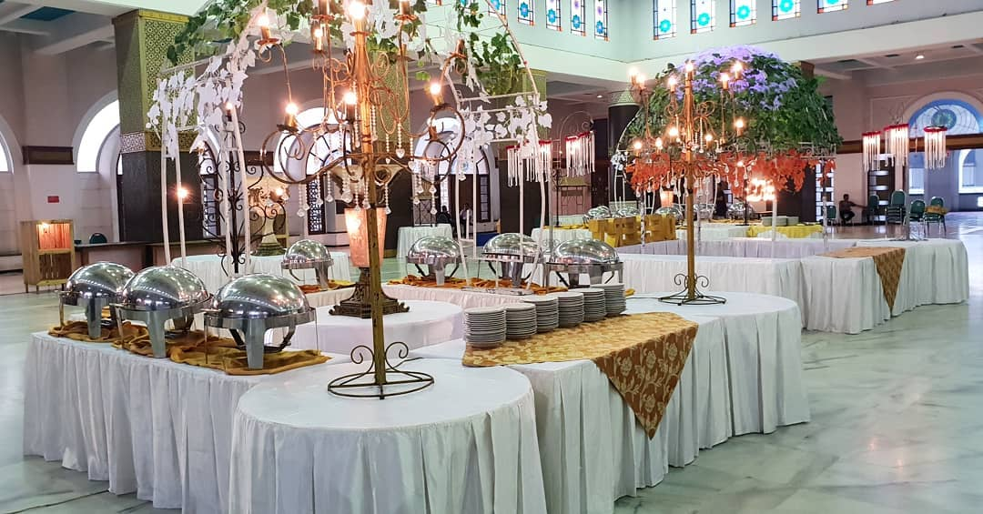

Phone : 0812 1533 9470

Address : Jl. Simo Tambaan Sekolahan No.99 A, Simomulyo, Kec. Sukomanunggal, Kota SBY, Jawa Timur 60281

Note : Contact for price (custom is available)

**Photographer & Videographer**

1. **Riomotret**

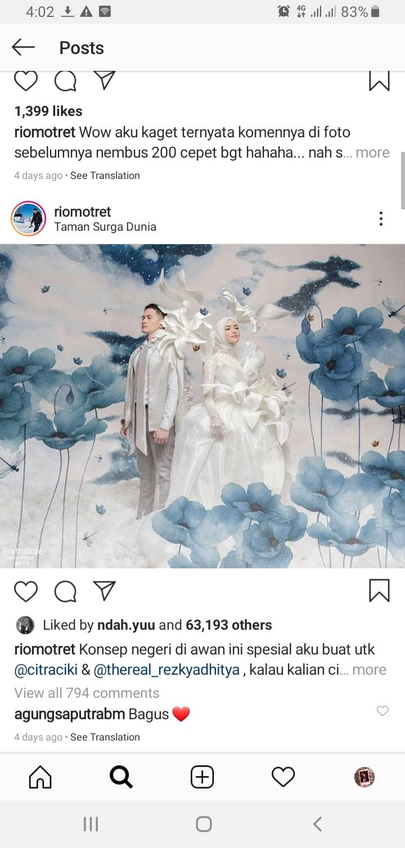

Price : IDR 30,000,000

Include : Full day, custom mural background, 2 movie video, max 20 printout (free custom size)

Phone : 085887332990

Address : Taman Pondok Jati K-20 , RT. 19 RW. 04 Geluran, Taman.

Note : contact for more pack

1. **Dierabachir Photography**

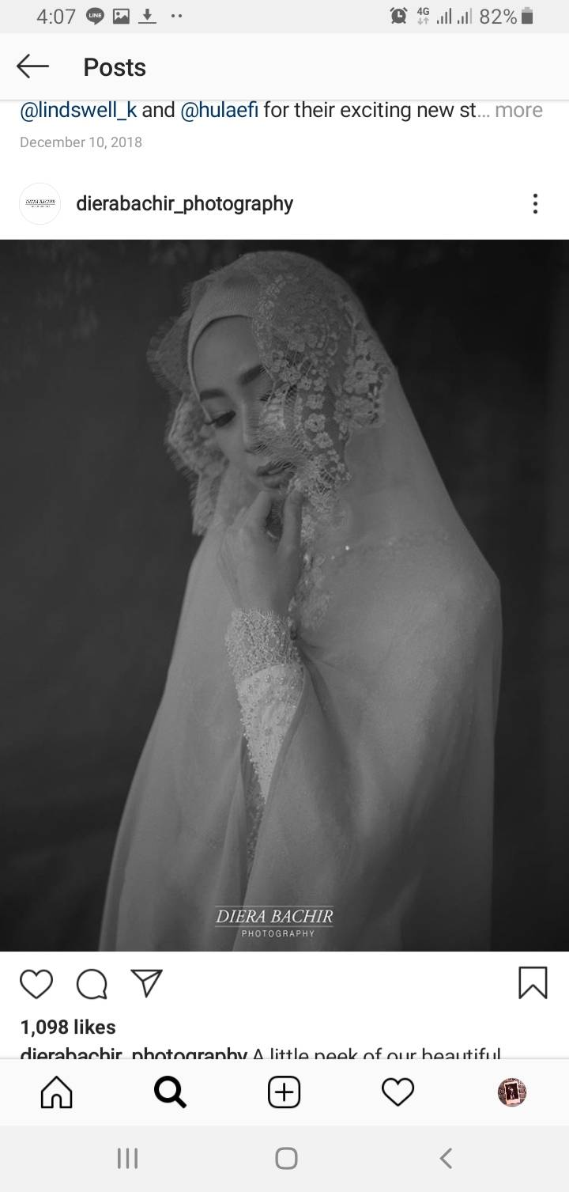

Price : IDR 25,000,000

Include : Full day, 2 movie video, max 20 printout (free custom size)

Phone : 08123479432

Address : Jl. Raya Nginden No.55

Note : contact for more pack

1. **FD Photography**



Price : IDR 15,000,000

Include : Full day, 1 movie video, max 10 printout (free custom size)

Phone : 087788435921

Address : Jl. Imam Bonjol 99

Note : contact for more pack

1. **Imagenic**

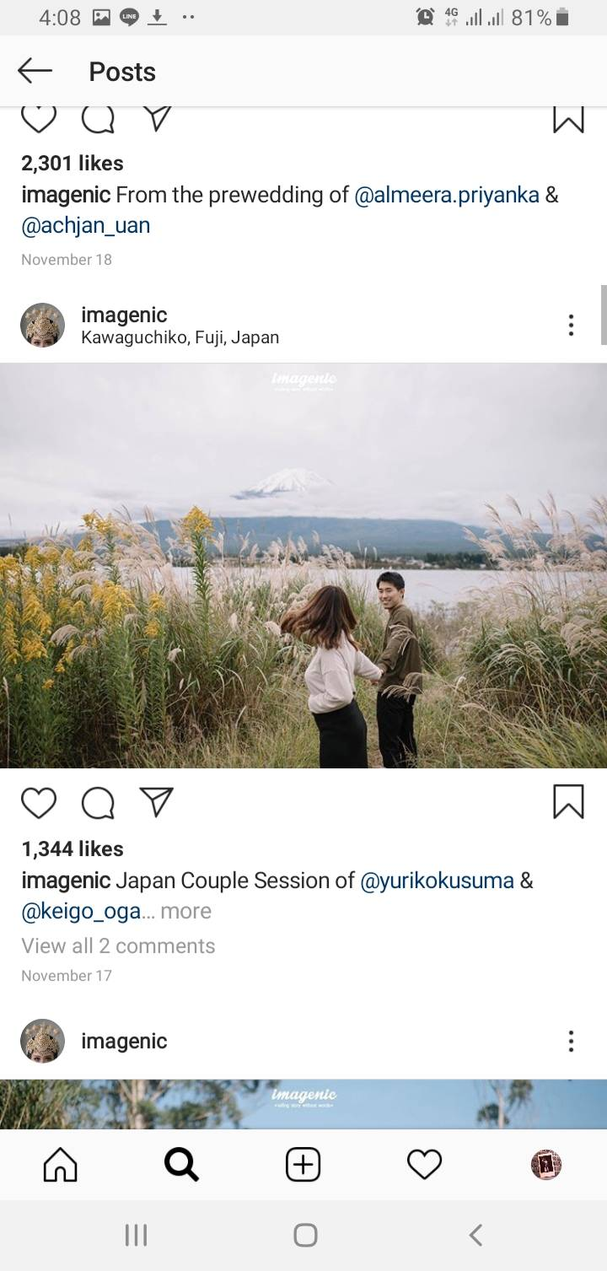

Price : IDR 15,000,000

Include : Photo full day, 1 movie video, 5 print out (A0)

Phone : 081287407345

Address : Jalan Arif Rahman Hakim, Keputih, Sukolilo

Note : contact for more pack

1. **Lemotion Photo**

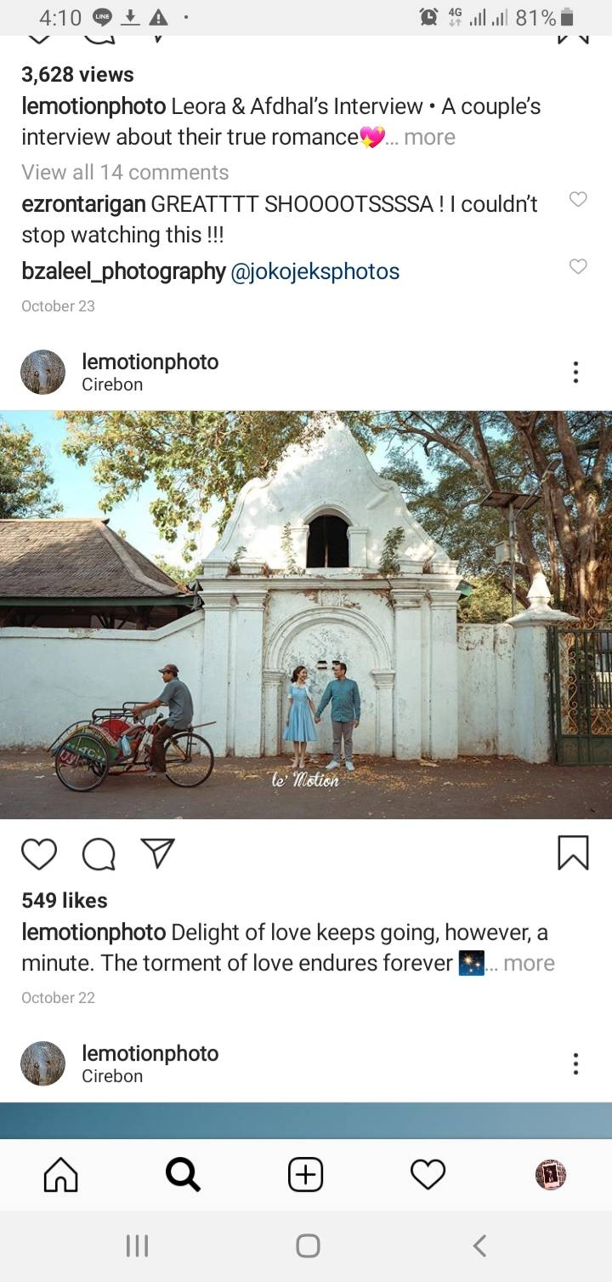

Price : IDR 17,000,000

Include : Photo full day, 1 movie video, 5 print out (A0) + free photo album

Phone : 087864936455

Address : Jalan Raya Mulyosari No.77

Note : contact for more pack